CIS 043

**Java Final Project**

**Snake Game**



Nikhil V., Timon S., Hanlin S., Anurag K.

# Introduction

This is the final project for Introduction to Java, CIS 043. Snake is a video game which originated during the late 1970s in arcades. To be precise, it is a concept, without details. Therefore there is no definitive version of the game. As a result, there are various versions of implementations for this game. Figure 1 shows a version of Snake. After it became the standard pre-loaded game on Nokia mobile phones in 1998, there was a resurgence of interest in the game as it found a larger audience. Thus, the Nokia version is used as the reference for the design of our Snake game.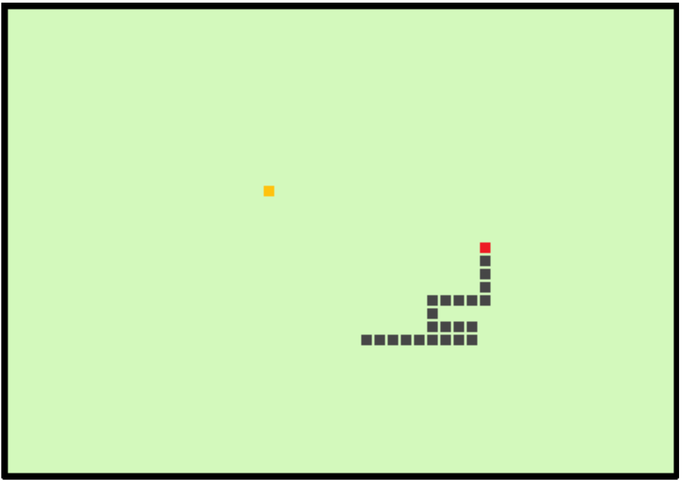

With a quick glance, most people would take this game as a simple game, which does not require sophisticated strategies. While, it does require advanced strategies when the ‘snake’ is long enough, due to inconspicuous solutions and increasing number of obstacles (the body of the ‘snake’ itself is also considered as obstacles, and with the game going, it increases, which means more obstacles are generated). So, to design a good AI will be the most challenging and important part of this project. This game is a culmination of the vast amount of information that we have gathered through this course. It uses all types of language, from int to boolean, all the way up to more complicated code, such as GUI and Graphics. We sincerely thank Professor Mortezaie for teaching us how to code.

# Code Descriptions

Snake.java

In the Snake class, we created the snake itself and programmed how the snake would move. Using various arrays and methods, the snake gains the ability to move in certain directions. The Snake class also includes code that adds on blocks to the snake and configures joints (corners on the snake that occur when the snake turns).

Board.java

The Board class encompasses all the major components of the program. The main goal is to create the “board” for which to play the game. In this process, it also displays the snake and the food, and describes the various actions used to control the snake. In addition, the Board class includes methods that describe food respawning, timers, endgame behaviors, and more, all created for the purpose of playing the game.

Food.java

As in the title of the file, this class is used mainly for creating the food. It also controls the location of respawn and provides set and get methods for the player’s score and the coordinates of the food.

Game.java

The final large class of the program, Game’s purpose is similar to the purpose of a “Main class” in a GUI. Game is used to combine all aspects of Snake.java, Food.java, and Board.java and display an actual game of Snake.

# Source Code

**Snake.Java:**

//Creating the snake

public class Snake {

// Stores the joints / body part locations for our snake in arrays

private final int[] x = new int[Board.getAllDots()];

private final int[] y = new int[Board.getAllDots()];

// Stores direction of our snake

private boolean movingLeft = false;

private boolean movingRight = false;

private boolean movingUp = false;

private boolean movingDown = false;

private int joints = 0; // Stores # of dots / joints the snake has (starts

// with 3)

//Set and get methods for the location of the snake

public int getSnakeX(int index) {

return x[index];

}

public int getSnakeY(int index) {

return y[index];

}

public void setSnakeX(int i) {

x[0] = i;

}

public void setSnakeY(int i) {

y[0] = i;

}

//Set and get methods for the movement of the snake

public boolean isMovingLeft() {

return movingLeft;

}

public void setMovingLeft(boolean movingLeft) {

this.movingLeft = movingLeft;

}

public boolean isMovingRight() {

return movingRight;

}

public void setMovingRight(boolean movingRight) {

this.movingRight = movingRight;

}

public boolean isMovingUp() {

return movingUp;

}

public void setMovingUp(boolean movingUp) {

this.movingUp = movingUp;

}

public boolean isMovingDown() {

return movingDown;

}

public void setMovingDown(boolean movingDown) {

this.movingDown = movingDown;

}

//Set and get methods for the joints of the snake

public int getJoints() {

return joints;

}

public void setJoints(int j) {

joints = j;

}

//Method for how the snake moves

public void move() {

//Continues to loop for every joint the snake has

for (int i = joints; i > 0; i--) {

// Moves the joints of the snake 'up the chain'

// Meaning, the joint of the snake all move up one

x[i] = x[(i - 1)];

y[i] = y[(i - 1)];

}

// Moves snake to the left

if (movingLeft) {

x[0] -= Board.getDotSize();

}

// To the right

if (movingRight) {

x[0] += Board.getDotSize();

}

// Down

if (movingDown) {

y[0] += Board.getDotSize();

}

// And finally up

if (movingUp) {

y[0] -= Board.getDotSize();

}

// Dotsize represents the size of the joint, so a pixel of DOTSIZE (25)

// gets added on to the snake in that direction

}

}

**Board.Java:**

//Creating the board for the game

import java.awt.Color;

import java.awt.Dimension;

import java.awt.Font;

import java.awt.FontMetrics;

import java.awt.Graphics;

import java.awt.Toolkit;

import java.awt.event.ActionEvent;

import java.awt.event.ActionListener;

import java.awt.event.KeyAdapter;

import java.awt.event.KeyEvent;

import javax.swing.JPanel;

import javax.swing.Timer;

import java.security.SecureRandom;

public class Board extends JPanel implements ActionListener {

// TODO: Implement a way for the player to win

// Holds height and width of the window

private final static int BOARDWIDTH = 1000;

private final static int BOARDHEIGHT = 980;

// Used to represent pixel size of food & our snake's joints

private final static int PIXELSIZE = 25;

// The total amount of pixels the game could possibly have.

// We don't want less, because the game would end prematurely.

// We don't more because there would be no way to let the player win.

private final static int TOTALPIXELS = (BOARDWIDTH * BOARDHEIGHT)

/ (PIXELSIZE * PIXELSIZE);

//Random number generator used later

SecureRandom randomNumbers = new SecureRandom();

// Check to see if the game is running

private boolean inGame = true;

// Timer used to record tick times

private Timer timer;

// Used to set game speed, the lower the #, the faster the snake travels

// which in turn makes the game harder.

private static int speed = 45;

// Instances of our snake & food so we can use their methods

private Snake snake = new Snake();

private Food food = new Food();

public Board() {

addKeyListener(new Keys());

setBackground(Color.BLACK);

setFocusable(true);

setPreferredSize(new Dimension(BOARDWIDTH, BOARDHEIGHT));

initializeGame();

}

// Used to paint our components to the screen

@Override

protected void paintComponent(Graphics g) {

super.paintComponent(g);

draw(g);

}

// Draw our Snake & Food (Called on repaint()).

void draw(Graphics g) {

int x = randomNumbers.nextInt(6);

// Only draw if the game is running / the snake is alive

if (inGame == true) {

switch (x){ // Make food rainbow

case 0: g.setColor(Color.PINK);

break;

case 1: g.setColor(Color.BLUE);

break;

case 2: g.setColor(Color.RED);

break;

case 3: g.setColor(Color.GREEN);

break;

case 4: g.setColor(Color.WHITE);

break;

case 5: g.setColor(Color.ORANGE);

break;

case 6: g.setColor(Color.YELLOW);

break;

}

g.fillRect(food.getFoodX(), food.getFoodY(), PIXELSIZE, PIXELSIZE); // food

// Draw our snake.

for (int i = 0; i < snake.getJoints(); i++) {

// Snake's head

if (i == 0) {

g.setColor(Color.GREEN);

g.fillRect(snake.getSnakeX(i), snake.getSnakeY(i),

PIXELSIZE, PIXELSIZE);

// Body of snake

} else {

g.fillRect(snake.getSnakeX(i), snake.getSnakeY(i),

PIXELSIZE, PIXELSIZE);

}

}

// Sync our graphics together

Toolkit.getDefaultToolkit().sync();

} else {

// If we're not alive, then we end our game

endGame(g);

}

}

void initializeGame() {

snake.setJoints(3); // set our snake's initial size

// Create our snake's body

for (int i = 0; i < snake.getJoints(); i++) {

snake.setSnakeX(BOARDWIDTH / 2);

snake.setSnakeY(BOARDHEIGHT / 2);

}

// Start off our snake moving right

snake.setMovingRight(true);

// Generate our first 'food'

food.createFood();

// set the timer to record our game's speed / make the game move

timer = new Timer(speed, this);

timer.start();

}

// if our snake is in the close proximity of the food..

void checkFoodCollisions() {

if ((proximity(snake.getSnakeX(0), food.getFoodX(), 20))

&& (proximity(snake.getSnakeY(0), food.getFoodY(), 20))) {

// Add a 'joint' to our snake

snake.setJoints(snake.getJoints() + 1);

// Create new food

food.createFood();

food.getScore();

}

}

// Used to check collisions with snake's self and board edges

void checkCollisions() {

// If the snake hits its' own joints..

for (int i = snake.getJoints(); i > 0; i--) {

// Snake cant intersect with itself if it's not larger than 5

if ((i > 5)

&& (snake.getSnakeX(0) == snake.getSnakeX(i) && (snake

.getSnakeY(0) == snake.getSnakeY(i)))) {

inGame = false; // then the game ends

}

}

// If the snake intersects with the board edges..

if (snake.getSnakeY(0) >= BOARDHEIGHT) {

inGame = false;

}

if (snake.getSnakeY(0) < 0) {

inGame = false;

}

if (snake.getSnakeX(0) >= BOARDWIDTH) {

inGame = false;

}

if (snake.getSnakeX(0) < 0) {

inGame = false;

}

// If the game has ended, then we can stop our timer

if (!inGame) {

timer.stop();

}

}

void endGame(Graphics g) {

// Create a message telling the player the game is over

String message = "Game over. Press enter to play again.";

String message2 = "Total score is: " + (food.getScore() - 5);

food.setScore(0);

// Create a new font instance

Font font = new Font("Serif", Font.ROMAN_BASELINE, 30);

FontMetrics metrics = getFontMetrics(font);

Font scorefont = new Font("Serif", Font.ROMAN_BASELINE, 30);

FontMetrics scoremetrics = getFontMetrics(scorefont);

// Set the color of the text to red, and set the font

g.setColor(Color.cyan);

g.setFont(font);

g.drawString(message, (BOARDWIDTH - metrics.stringWidth(message)) / 2,

BOARDHEIGHT / 3);

g.setColor(Color.cyan);

g.setFont(scorefont);

// Draw the message to the board

g.drawString(message2, (BOARDWIDTH - scoremetrics.stringWidth(message2)) / 2, BOARDHEIGHT / 2);

System.out.println("Game Ended");

}

// Run constantly as long as we're in game.

@Override

public void actionPerformed(ActionEvent e) {

if (inGame == true) {

checkFoodCollisions();

checkCollisions();

snake.move();

System.out.println(snake.getSnakeX(0) + " " + snake.getSnakeY(0)

+ " " + food.getFoodX() + ", " + food.getFoodY());

}

// Repaint or 'render' our screen

repaint();

}

private class Keys extends KeyAdapter {

@Override

public void keyPressed(KeyEvent e) {

int key = e.getKeyCode();

if ((key == KeyEvent.VK_LEFT) && (!snake.isMovingRight())) {

snake.setMovingLeft(true);

snake.setMovingUp(false);

snake.setMovingDown(false);

}

if ((key == KeyEvent.VK_RIGHT) && (!snake.isMovingLeft())) {

snake.setMovingRight(true);

snake.setMovingUp(false);

snake.setMovingDown(false);

}

if ((key == KeyEvent.VK_UP) && (!snake.isMovingDown())) {

snake.setMovingUp(true);

snake.setMovingRight(false);

snake.setMovingLeft(false);

}

if ((key == KeyEvent.VK_DOWN) && (!snake.isMovingUp())) {

snake.setMovingDown(true);

snake.setMovingRight(false);

snake.setMovingLeft(false);

}

if ((key == KeyEvent.VK_ENTER) && (inGame == false)) {

inGame = true;

snake.setMovingDown(false);

snake.setMovingRight(false);

snake.setMovingLeft(false);

snake.setMovingUp(false);

initializeGame();

}

}

}

private boolean proximity(int a, int b, int closeness) {

return Math.abs((long) a - b) <= closeness;

}

public static int getAllDots() {

return TOTALPIXELS;

}

public static int getDotSize() {

return PIXELSIZE;

}

}

**Game.Java:**

**Food.Java:**

# Concepts

|  |  |
| --- | --- |
| Learned During Class | New |
| * **All Code**   + If/Else Statements   + For Statements   + Set and get methods   + Public/Private/Protected Methods   + Static/Void/Final Methods & Ints   + Public/Non-Public Classes   + @Override * **Snake.Java**   + Arrays * **Board.Java**   + GUI   + SecureRandom   + Switch Statements   + Graphics/Graphics2D   + Superclasses/Subclasses   + Timer | * **Snake.java**   + Boolean * **Board.java**   + setFocusable()   + setPreferredSize()   + Dimension()   + java.awt.Toolkit   + KeyAdapter   + KeyEvent   + KeyListener * **Game.java**   + EventQueue   + Runnable()   + setLocationRelativeTo() |

# Conclusion

Throughout the course of this project, we have combined many different concepts that we have learned and used them to make a game. The game has tested our ability to use existing knowledge and apply it in different ways. In addition, it has also pushed us to discover multiple new methods, variables, and classes that we have since used to run the game. Without these applications, we would not have been able to make the game run. While we were coding we encountered several errors and problems with our code. Together, we worked as a team and resolved these problems by asking others and researching online. Although the process was tiring, it was worth it once we had completed our game. Being able to play the snake game that we created ourselves was quite satisfying. All in all, this final project was a great experience that allowed our group to apply the knowledge we have learned, and use it to create a fun yet simple game.